M A U D C H R I S T M A S P A R A D E
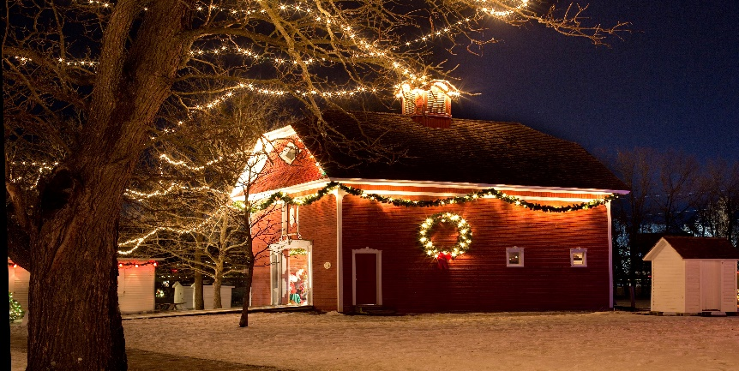
“SMALL TOWN CHRISTMAS”

ALL PARADE PARTICIPANTS ARE REQUIRED TO BE AT THE MAUD HIGH SCHOOL PARKING LOT BY 2:00 P.M. “TOYS FOR TOTS” DONATIONS WILL BE COLLECTED AT THE SCHOOL.
You will be instructed at that time where to line up for the parade procession.

Organization

Contact Person Phone No.

All drivers of vehicles must be at least 18 years of age and have a current driver’s license. Participants with horses must be able to provide a current negative equine coggins test. Papers will be checked.

For the same consideration, I assume all risks associated with participation in the parade and hereby release and hold harmless all of the following, who are hereafter called “the indemnified parties,: namely the City of Maud, their respective directors, officers, employees, agents, successors, assigns, member and volunteer workers from and against any and all claims, damages, liabilities, costs and expenses, including reasonable attorney fees, arising out of my participation in the parade, including without limitation any personal injuries or damage to my property which I may incur as a result of participation in the parade.
I agree that this Waiver, Release and Indemnification Agreement shall be governed by the laws of State of Texas and that the venue for litigation involving the indemnified parties shall be in a court of competent jurisdiction in Bowie County.

Signature: Date:
Waiver, Release and Indemnification Agreement for Maud Christmas Parade Participants
2021 M A U D C H R I S T M A S P A R A D E
“SMALL TOWN CHRISTMAS”
SUNDAY DECEMBER 5, 2021

The 2021 Christmas Parade is sponsored by the Maud Volunteer Fire Department and the City of Maud. The MVFD will be hosting a Baked Potato Dinner at the Maud Fire Station prior to the parade. Potatoes will be served from 11:00 am to 2:00 pm. Santa will be at the Fire Station after the parade.
We would love to have lots of floats and participation for this year’s parade! Entry forms for the parade may be picked up at Maud City Hall. Line up for the parade will begin at 2:00 pm, judging at 2:30 pm and the parade will start at 3:00 pm. Trophies will be awarded for 1st, 2nd and 3rd place. Please complete and return your entry forms to City Hall or Judge Spelling’s office.
If you have any questions, please contact City Hall @ 903-585-2294 or Judge Susie Spellings @ 903-585-5428
PLEASE REMEMBER A “TOYS FOR TOTS” DONATION FOR THE PARADE ENTRY… THE COLLECTION BOX WILL BE @ THE SCHOOL.
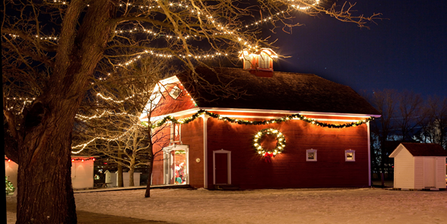
MERRY CHRISTMAS & HAPPY NEW YEAR

